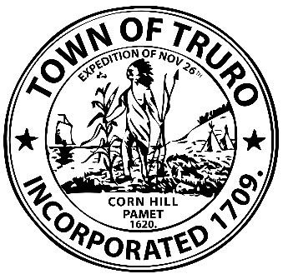

PRESS RELEASE

The Town of Truro along with partners The Community Builders, Inc. and Community Housing Resource, Inc. celebrate the groundbreaking of the Cloverleaf Development.

The 43-apartment development will deliver 39 income-restricted and
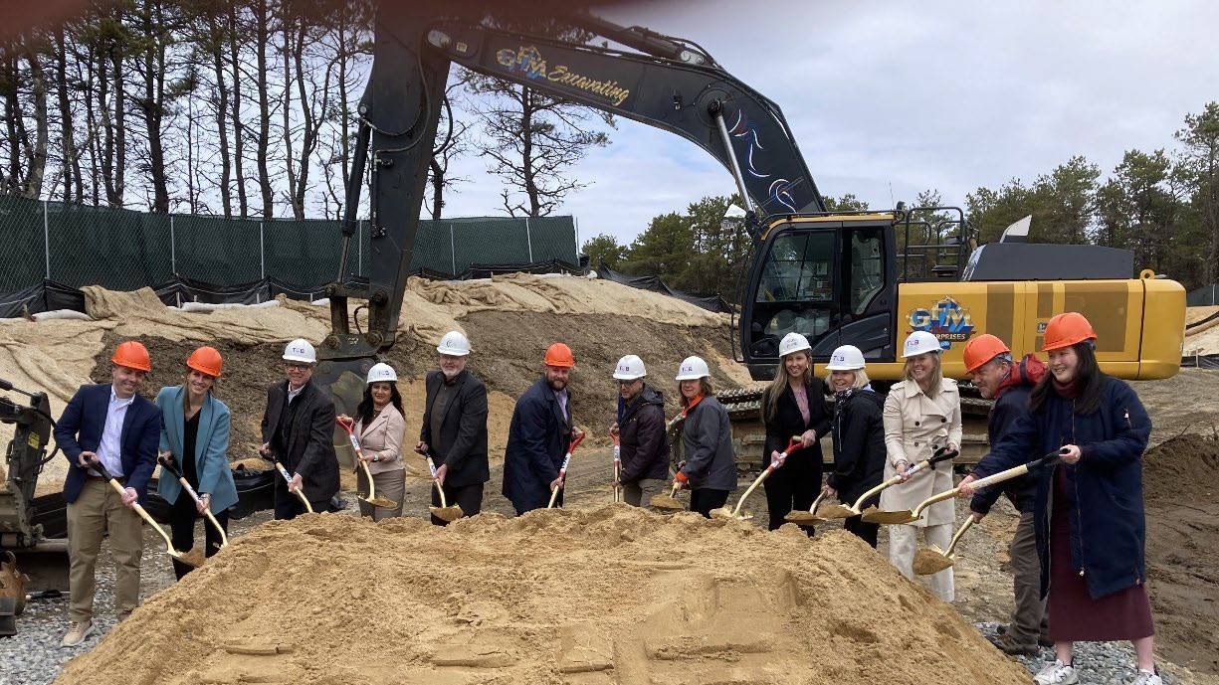
four market-rate homes for year-long renters on the Outer Cape.
(L to R: Nick Christofano, Annemarie Murphy, Bart Mitchell, Rachana Crowley, Ted Malone, Julian Cyr, Paul Wisotzky, Susan Areson, Kelly Clark, Sheila Lyons, Patricia Belden, Clark Ziegler, Tiffany Leung; photo by StudioGregg Photography)
April 14, 2025 – Truro, Massachusetts – On Friday, April 11, 2025, The Town of Truro along with partners The Community Builders, Inc. (TCB) and Community Housing Resource, Inc. (CHR), celebrated the groundbreaking of the Cloverleaf development. The new construction of this multifamily development, located at 22 Highland Road, will offer year-round, sustainable housing for families and individuals, including 39 income-restricted and four market-rate homes.

"It's exciting to see activity at the Cloverleaf site after years of delay. It's a promising step forward as our entire region struggles to provide safe and attainable housing for workers at all income levels and seniors who want to downsize,” said Susan Areson, Truro Select Board Chair. “This development will provide 43 more homes for individuals and families who have ties to Truro and Cape Cod. We look forward to welcoming them to our new neighborhood in Truro."

With a focus on workforce housing and alleviating the lack of year-long affordable housing on the Outer Cape, today’s milestone represents the culmination of nearly ten years of persistence and collaboration to acquire the site, successfully navigate a global pandemic, resolve legal action, and close a multimillion-dollar funding gap.

“I've been involved in the Cloverleaf project from the very beginning and now with the groundbreaking and construction underway, it is a certainty that Cloverleaf will become a reality,” said Paul Wisotzky, Cloverleaf Oversight Committee. “It's been a longtime in the making and a testament to the diligence, persistence, and hard work of so many in our community - from town staff to elected and appointed officials to residents - all who understood and understand how Cloverleaf, and affordable housing in general, will make Truro a better, stronger, and more sustainable year-round community.”

Located off Route 6, the site was owned by the Massachusetts Department of Transportation and was formerly part of the State Highway road-layout. In 2018, the site was conveyed to the Town of Truro for affordable housing purposes. Cloverleaf is located less than a mile from Sally’s Way, a 16-apartment property currently owned by CHR and managed by TCB.

“As the developer, Community Housing Resource acknowledges the community input that improved the project, and, I am so proud of the exceptional design, development and construction teams that got us to where we are today,” said Ted Malone, President of Community Housing Resource, Inc. “Getting to financial feasibility for this project required extensive commitments from funding sources including the Town of Truro, Barnstable County, the Commonwealth, and Federal resources. We’re so grateful for their financial support and commitment to the Outer Cape.”

Cloverleaf development will include 22 one-bedroom apartments, 17 two-bedroom apartments, and four three-bedroom apartments. Of the 39 income-restricted units, six units will be affordable to households up to 30% Area Median Income (AMI), 29 units up to 60% AMI, and four up to 100% AMI.

“I’ve watched over the last 20 years as the towns of the Outer Cape, the area I have always called home, have grown more and more unaffordable for families and working people. It’s been heartbreaking,” said State Senator Julian Cyr, (MA-Cape & Islands District), “However, today marks the beginning of a much-needed transformation in Truro, and I am so proud that my hometown is finally taking that critical step forward with Cloverleaf. This

project will provide essential affordable housing options, allowing families to stay in the communities they love, where they have deep roots.”

The Town requested – through the Massachusetts Executive Office of Housing and Livable Communities – a 70% local Truro residency preference at initial lease-up. This preference includes Truro residents, municipal employees, employees of businesses located in Truro, or individuals who have children attending schools in Truro.

“This groundbreaking is a monumental milestone for our community and is the result of nearly ten years of persistence from community members, elected and appointed officials, Town staff, the development team, grant partners, and the project lenders,” said Kelly Clark, Truro Acting Town Manager, “Seeing this project come to fruition is an inspiring example of how we can work together to better our community and take steps towards making Truro the vibrant and sustainable place we have collectively envisioned.”

The Cloverleaf development will feature a state-of-the art sewage treatment facility, EV charging stations, Passive House and Enterprise Green Communities building envelopes with highly efficient electric Heat Pumps and ERV (energy recovery ventilation). Approximately 75% of the energy needs of the development will be provided by solar/photovoltaic power, without reliance on fossil fuels.

"MHP is pleased to be providing permanent financing for Cloverleaf, which will help address the urgent need for affordable and workforce rental housing on the Outer Cape, “said Clark Ziegler, Executive Director of Massachusetts Housing Partnership. “Our financing culminates a decade of work by MHP to assess the potential for affordable housing on this site, facilitate the transfer of land from the state to the Town of Truro, and help the town select a strong development team."

An all-electric development, Cloverleaf will consist of ten buildings including: six two-unit townhouse buildings, two four-unit buildings, one seven-unit townhouse building, and one low-rise multi-family, elevator apartment building that houses sixteen units. Development amenities will also include a community room, management office and common laundry facility.

“The Community Builders (TCB) is thrilled to join with our partners to celebrate the groundbreaking of Cloverleaf. This new community will offer much-needed year-round housing opportunities for families and individuals,” said Rachana Crowley, TCB Vice President of Development. “The development of Cloverleaf represents an important step forward in addressing the housing crisis in Truro and across the Outer Cape.”

For additional images contact Katie Riconda at the Town of Truro, 774-722-9867, pio@truro-ma.gov
About the Town of Truro
Located in Barnstable County, Massachusetts, the Town of Truro is about two hours outside of Boston. The town is named after Truro in Cornwall, United Kingdom. Its name among the Native American communities of Cape Cod was Pamet, or Payomet, a name that still refers to an area around the town center known as the Pamet Roads. Truro's year-round population remains under 3,000 but can soar to 15,000 to 20,000 people during summer months as Truro is an ideal vacation spot being just minutes from the tip of Cape Cod and Provincetown.

About The Community Builders, Inc.
The Community Builders’ mission is to build and sustain strong communities where all people can thrive. Our mission-driven businesses work with partners to develop, finance and operate residential communities, neighborhood amenities and opportunity programs for families, seniors and adults with disabilities. Since 1964, we have advanced housing that is fair for all through award-winning affordable and mixed-income communities and our pioneering Community Life model for resident success. Today, our ownership and management portfolio include over 14,000 apartment homes. Anchored by offices in Boston, Chicago, Columbus, New York and Washington D.C., we operate across 15 states.

About Community Housing Resource, Inc.
Community Housing Resource, Inc. was formed in 1996 as a private company whose mission is to provide affordable housing opportunities for year-round residents of the Outer Cape. We develop and manage rental housing in Provincetown, Truro, and Wellfleet working in partnership with many public and private entities to provide and maintain quality homes. CHR has created 160 year-round homes, 61 art studio workspaces, and 10 commercial spaces. CHR is in the process of developing an additional neighborhood on Paine Hollow Road in Wellfleet. Upon its completion, CHR will have created over 200 homes, of which more than 77.5% are affordable.

