LOG OF BALLSTON BEACH, TRURO, MA STORM EVENTS for
PAMET RIVER MARSH RESTORATION STUDY; DEC-2016-MAY-2017;

Storm #1 Non –Overwash Event –
, 2017; Data to be added.

Storm #2 – Overwash Event - Tuesday January 24, 2017; Data to be added. Add data regarding ocean wave height, number of high storm tides, and approximate depth of overwash if available from local observers)

Storm #3 Thursday, February 9th, 2017, Figures 1-4 (two for wind / wave height {early part of storm & later part of storm}, two figures for tide cycle, early storm & later storm)

Figure 1. Wind / Wave height, Early Part of Storm
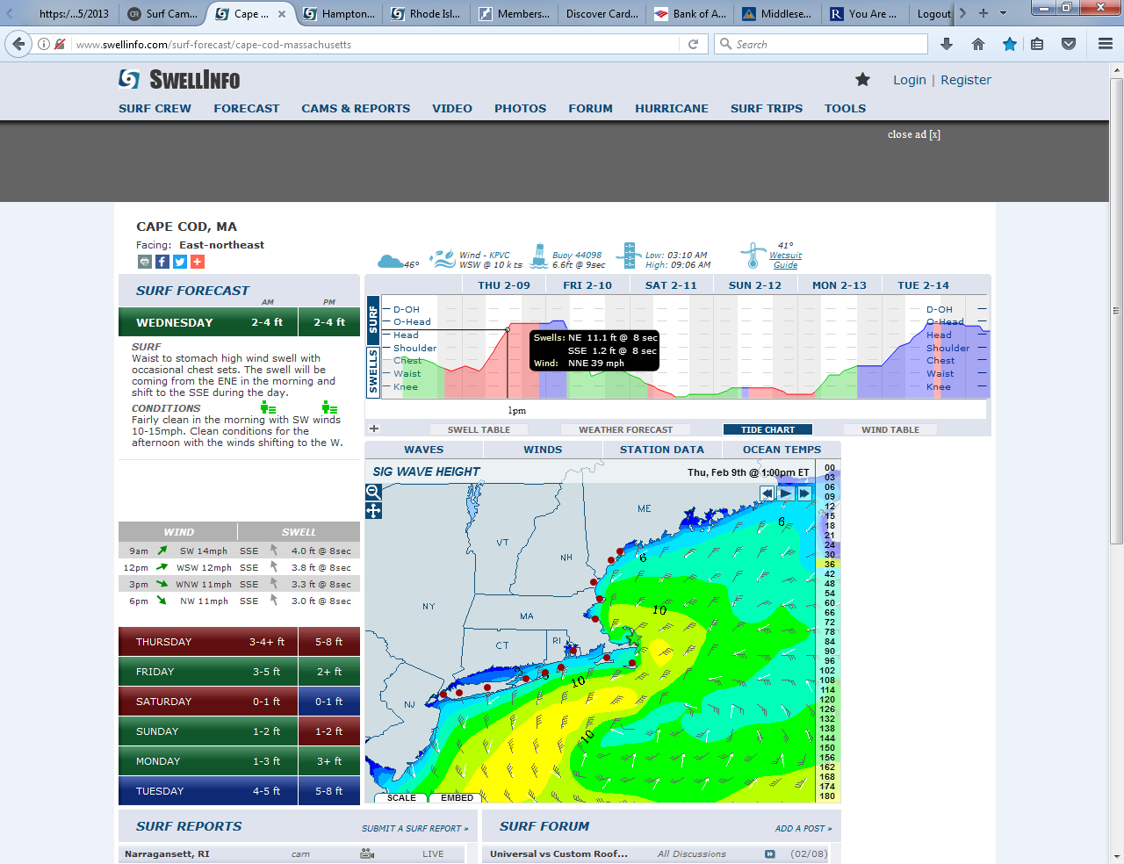
Figure 2. Wave Height w-Tide Cycle, Early Part of Storm
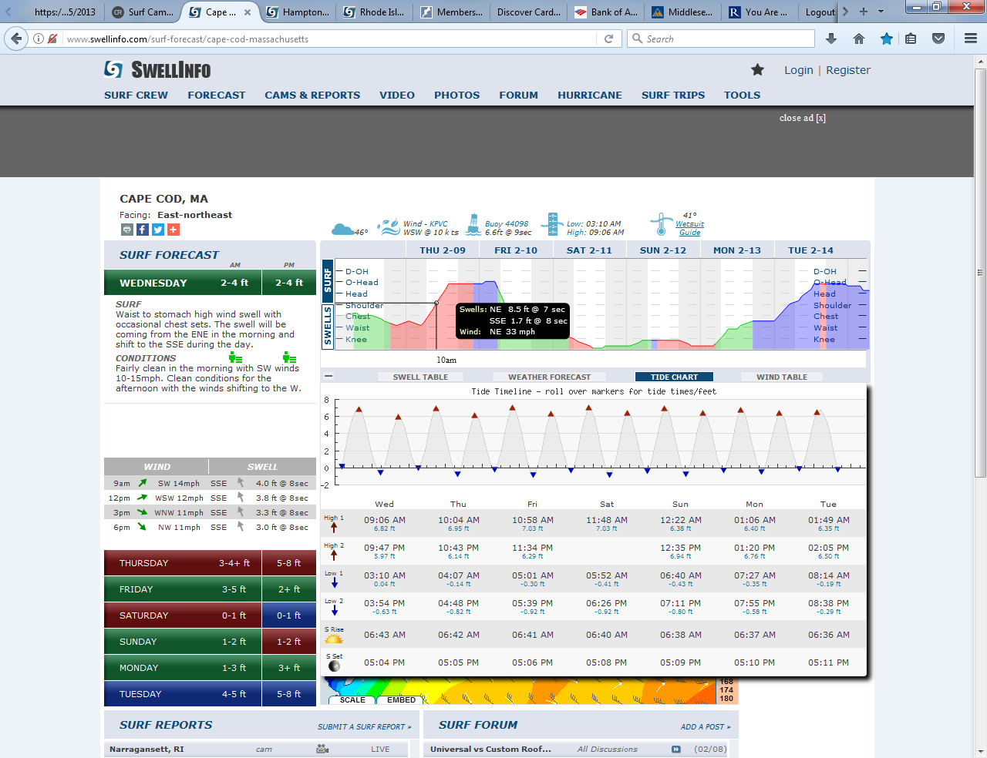
Figure 3. Wind / Wave height, Late Part of Storm
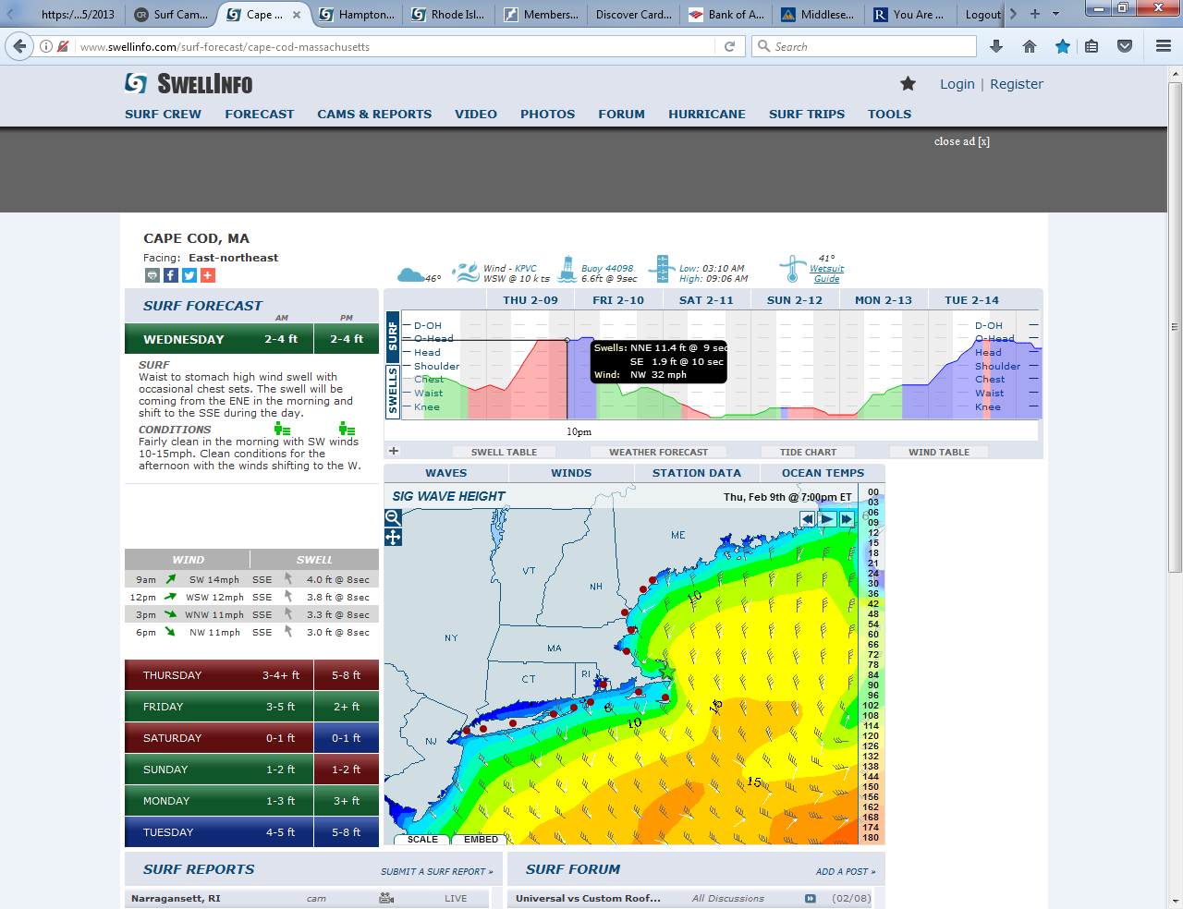
Figure 4. Figure 2. Wave Height w-Tide Cycle, Early Part of Storm
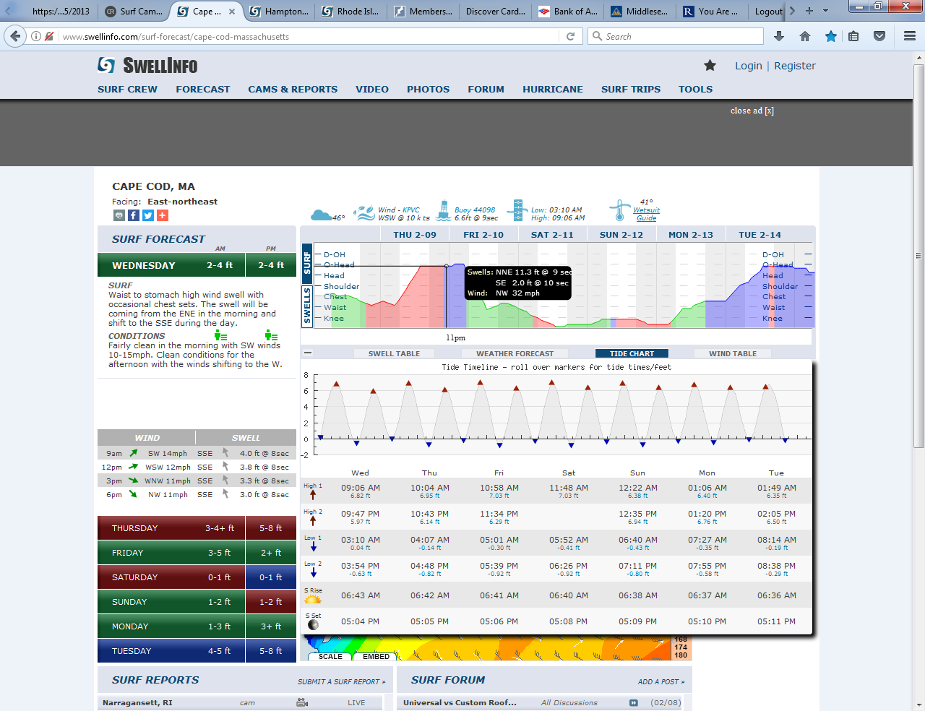
Storm #4 Thursday, March 4th, 2017, Assumed NON-OVERWASH Event with NW Wind Reducing Wave Run-up. Figures 1.
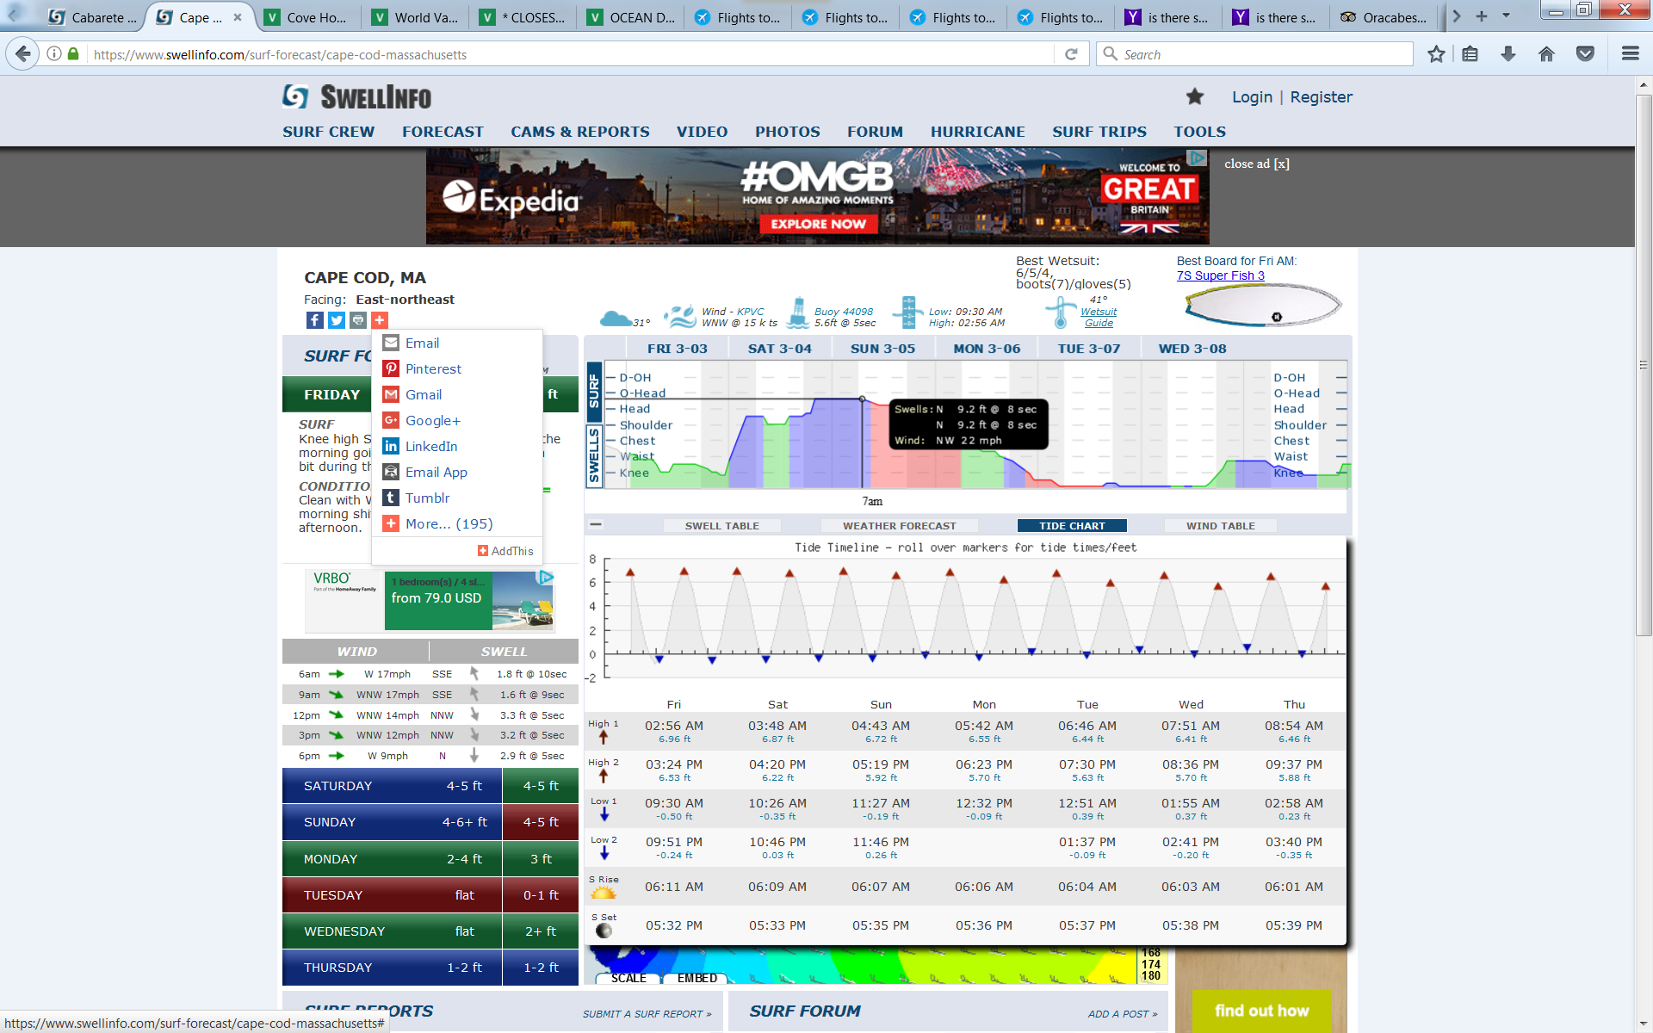
Storm #5 Tuesday, March 14th, 2017, Likely OVERWASH Event with 52 mph E wind coinciding with 2 pm high tide, increasing Wave Run-up. Figure 1. Below
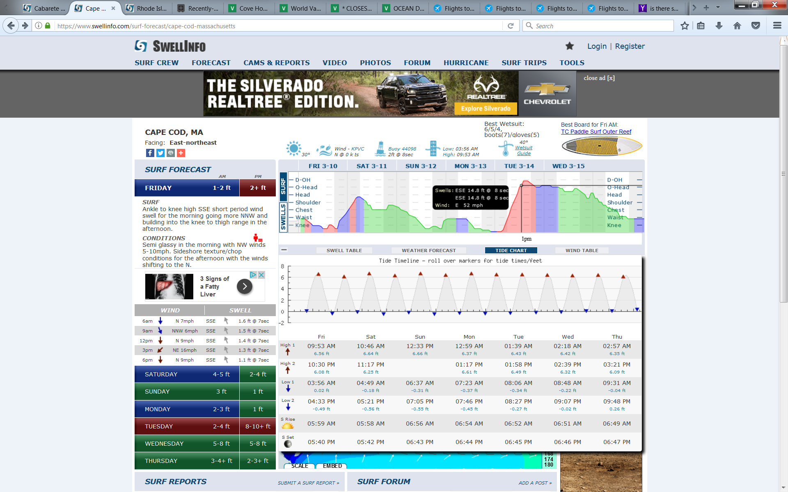
Storm #6 Hurricaine Maria Passes SE of New England, Tuesday-Thursday, September 26-28, 2017. Likely Non- OVERWASH Event despite significant wave heights from Maria. Winds are not contributing to wave run up as on Wednesday are light Onshore, and Thursday light offshore.

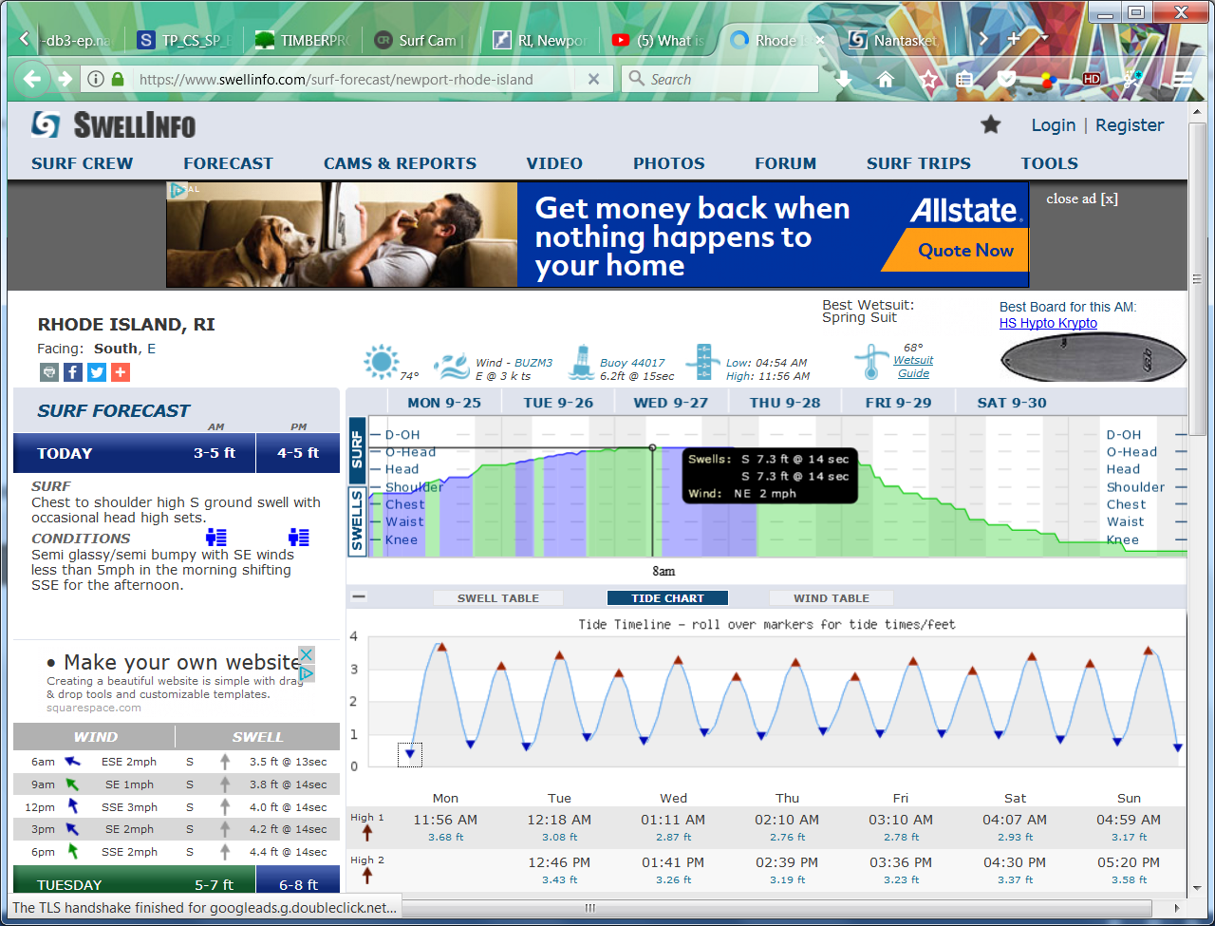

Storm #7 Friday Jan 5th, 2018 Likely OVERWASH Event with 35 mph E wind coinciding with high tide, increasing Wave Run-up. Figure Below;

